|  |  |  |  |  |
| --- | --- | --- | --- | --- |
|  | |  | | |
| Nombre del Maestro(a): Nohemi Cardenas Z. | Calificación: _____________________ | | | |
|  | |  |  |  |
| Nombre de Alumno(a): Victor Manuel Galvan Covarrubias | |  | Fecha: | 04/06/2021 |

**PART 1**

**Instructions: Write the following sentences in future passive voice. (5 points)**

1. The store will not accept cash anymore.

Cash will not be accepted by the store anymore.

1. The salesperson will process your application.

Your application will be processed by the salesperson.

1. He’ll give you the details about the process.

The details about the process will be given by him.

1. Robert won’t build a new house this year.

A new house won’t be built by Robert this year.

1. Will they call you this week?

Will you be called this week by them?

**Instructions: Read the following situation and write sentences in Future Passive Voice. UNDERLINE THE DIRECT OBJECT in each sentences. (10 points)**

Imagine you are a candidate to be the mayor (el *alcalde* o *presidente municipal*)

of your city. Write some of the changes that you tell the people will be done in your city to improve in different areas. Here are some ideas on areas where you can make improvements, although you may write in other areas not related to these, but that obviously relate to making improvements in your city.

* Crime
* Environment (green areas, pollution,
* Improve city aspect
* Information Resources
* Employment
* Education

1. The new road of the Flores avenue will be built by mayor Victor.
2. Old Hospitals will be renewed for more people to come.
3. Self-defense won’t be punished by the police in case of robbery.
4. Poor dog shelters will be cleaned and supported by the government.
5. English teachers will be paid extra hours for their commitment to the community.

**PART 2**

**Instructions: Write a complete sentence based on the images. Include the number of adjectives indicated. Use DIFFERENT ADJECTIVES, you can’t repeat. UNDERLINE or put in a different color the adjectives. (10 points)**



**For example:**

**Use 4 adjectives**

**He is a lovely, tall, young, Spanish soccer player.**

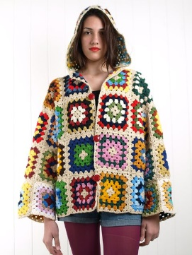

1. Use 3 adjectives

She is a **boring, young, American** woman.



1. Use 4 adjectives

This is a **comfortable, small, old, Mexican** city.

(Image represents the city of San Luis Rio Colorado)

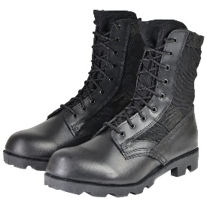

1. Use 2 adjectives

This are some **useful black** boots.

1. Use 5 adjectives

The **horrible, huge, flat, fashioned, black** dress of Jennifer Lawrence is the same one she had last time.



1. Use 3 adjective

The **overrated, big, brand new** computer of apple is burning.

**PART 3**

**Instructions: Write a complete sentences using 2 COMPUND ADJECTIVES in each one. UNERLINE the COMPUND ADJECTIVE. DO NOT REPEAT the adjectives. (3 points)**

1. The project is almost finished and I have not written the **twenty-page** document that I am supposed to show it to the **middle-age** teacher.
2. My **short-haired** grandmother has come to our **well-made** house.
3. The **highly-respected** teacher put the students to cut some **home-made** lemons.

**Instructions: Answer the following questions. Use at least 1 compound adjective in your answer. (2 points).**

1. Why are you studying this career?

This career has a famous characteristic of being **well-paid**. And I also liked the idea of a **four-year** career.

1. How are you feeling after more than a year with online classes because of the pandemic?

I feel very happy of returning to school because I always knew that this was a **short-term** pandemic. This is only a **fast-moving** stage of my life.